WHSLA 2025 Fall Board Meeting
Friday, November 7, 2025
10:00 am – 11:00 am
Virtual via Microsoft Teams

Call to Order
Meeting was called to order by Barb Ruggeri at 10:04 AM.

Roll Call
Rita Mitchell, Kelly Johnson, Brenda Fay, Karen Hanus, Hayley Severson, Barb Ruggeri, Jennifer Schram, Dora Davis, Michelle Harrell, Michele Matucheski, Jennifer Deal

Officers Reports

President's Report – Barb Ruggeri
This fall I surveyed members for their opinion on spending more money on Professional Development awards in 2026. I asked Professional Development Committee leader Dora Davis and Board Member at Large Michelle Harrell to review the responses and craft recommendations to present to the Fall Board Meeting for approval.
Will White, at-large-board member 25-26 resigned from WHSLA because of a job change to New Mexico. As per the bylaws, I appointed Jennifer Schram to complete his term. The website has been updated to reflect this change. Thank you, Jennifer, for stepping up and we appreciate your willingness to be a voting member of the board.
Will was the representative to UWM for Student Outreach. We would like to maintain those ties especially during the next six months as we hope to attract students to volunteer and participate at MLA 2026. See Barb if you are interested in being that contact person.
I precepted a graduate student intern in medical librarianship this past summer which was an unexpected role. As a result, I wasn’t able to develop a marketing plan for WHSLA this summer, however I am happy to work with Hayley if she would like to move forward with working with membership to determine our future goals and objectives for a sustainable organization.
I look forward to hosting the virtual business meeting in December. After the conclusion of the business meeting I will hand over the gavel to Hayley Severson to serve as President in 2026.
Respectfully submitted,
Barbara Ruggeri
WHSLA President 2025
Secretary’s Report and Approval of Spring 2025 Meeting Minutes – Jennifer Deal
2025 spring board meeting minutes presented by secretary, Jennifer Deal, and approved without corrections.
Treasurer's Report – Karen Hanus
We currently have a healthy balance between revenue and expenses, with a total balance of $19,321.77. See details of treasurer’s report below.

Prepared and submitted by Karen Hanus, Treasurer

Financial activity since last treasurer’s report
BEGINNING BALANCE | April 12, 2025 | $19,321.77
Expenses | April 12, 2025-November 3, 2025
 | Google | $54.61
 | Professional development award-Bradley (2024) | $445.50
 | Professional development award-Severson | $500.00
 | Professional development award-Koch
Total Expenses: |  | $1,500.11
Income | April 12, 2025-November 3, 2025
 | Membership Dues | $131.67
 | Interest from CD | $265.86
Total Income: |  | $397.53
ENDING BALANCE | November 3, 2025 | $18,219.19

Activities
CD/Money Market:

I moved $15,000 into a 12-month CD on October 3, 2024. I closed out the account on October 3, 2025 in consultation with Barb Ruggeri, WHSLA president. The CD was closed so that we have WHSLA’s full cash on hand available to us in case we determine that we will grant more professional development awards in 2026.

We made $525.77 in interest on the CD in a year (October 3, 2024-October 3, 2025).

Signatory:

On December 13, 2024, Liz Suelzer was added as a second signatory on WHSLA’s account at Associated Bank. At the same time, Robert Koehler was removed from the account.

Completed other routine tasks.
Action
This report requires no action by the board.

Karen recommends we consider another CD in the future, but it depends on what interest rates look like after MLA 2026. Barb thanked Karen for her initiative in taking care of high interest rates to grow our funds.

Members at Large – Michele Harrell and Jennifer Schram
Nothing to report.

Committee Reports

Communications Committee – Allan Barclay (list-serv), Kelly Johnson, Paije Wilson, and Michele Matucheski (blog), & Liz Suelzer (website)
The WHSLA Communications Committee manages the listserv, blog and website.
The WHSLA Listserv continues to be a tool to send messages and announcements to WHSLA Members. Allan Barclay, the WHSLA listserv admin, confirmed that 82 individuals are currently subscribed.
The WHSLA Blog acts as our WHSLA Newsletter. Bloggers post articles periodically, and Paije Wilson emails a summary to WHSLA Members with recent posts once or twice a month. Bloggers are Michele Matucheski, Paije Wilson, and Kelly Johnson. WHSLA Members are welcome to write articles or suggest content for the WHSLA Blog. Email any of us to get your articles or announcements posted to the WHSLA Blog. Special thanks to Brenda Fay who recently stepped down as our WHSLA Blogger after nearly 10 years.
Since The WHSLA Blog began in March of 2016, we’ve posted 1,054 articles that have logged over 346,000 views!
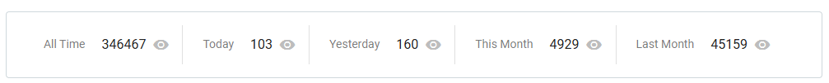
As of October 27, 2025, the WHSLA Blog has gotten over 94,400 Views in the last 12 months:

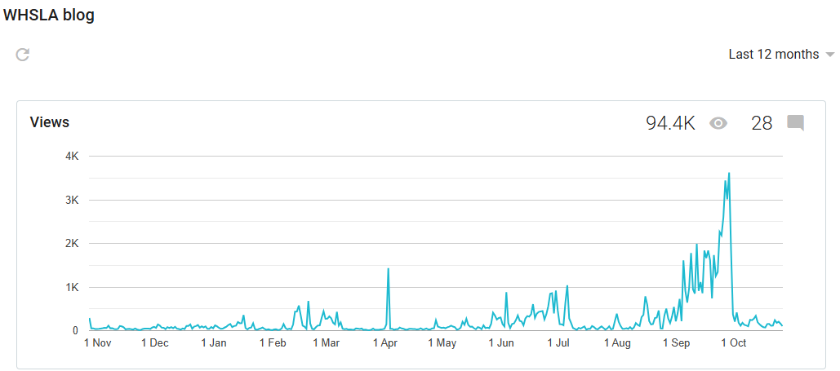
WHSLA Blog Stats (as of October 27, 2025):

Here are the posts with the most hits:
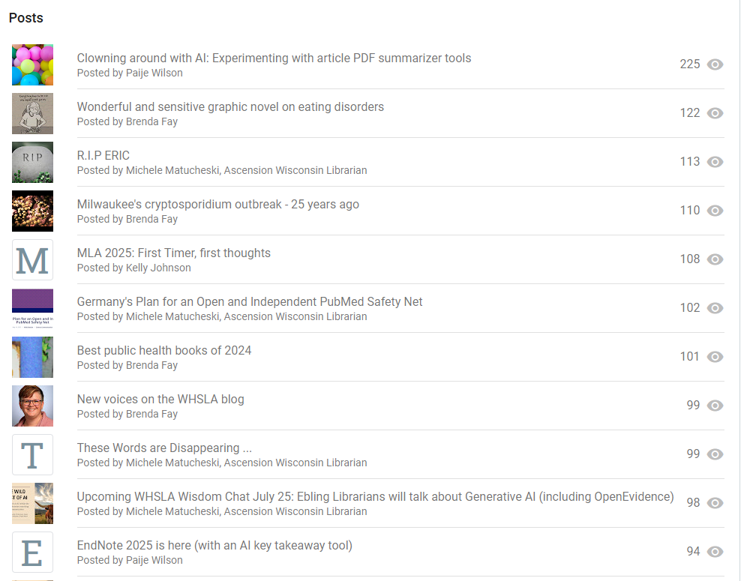

Liz Suelzer manages the WHSLA Website. Contact her if you notice any changes that need to be made to the website.
Respectfully submitted by Michele Matucheski on behalf of Allan Barclay, Liz Suelzer, Paije Wilson and Kelly Johnson.
Karen Hanus learned through the Midwest Chapter that the list-serv platform we use in WHSLA is going away next year, but she's not sure on exact timeframe. Miles Dietz-Castel at University of Iowa is the person that manages those, so he may be the person to contact about what is happening and when which will help. Hayley Severson said the University of Minnesota is also changing list-serv platforms so they might be a good resource. Michele Matucheski will also reach out to Allan Barclay to see if he has heard about this. He will be looking for someone to take this responsibility over next year.

WHSLA Wisdom Chats – Michele Matucheski
Wisdom Chats continue to be a valuable learning and sharing opportunity for WHSLA Members.
Michele Matucheski volunteered to be WHSLA Wisdom Chat Facilitator for 2025, while Barb Ruggeri was busy being WHSLA President. We hosted the following 4 virtual sessions in 2025:
The Library’s Role in Successful Implementation of System-wide Online Tools
By Karen Hanus and Liz Suelzer on October 24, 2025
(16 attendees)
Professional Growth in Data Services
By Ashley Zeidler of MCW Library on September 26, 2025
(10 attendees)
The Wild West of AI: A Critical Look at AI within the context of literature searching and summarization by Leslie Christensen, Susan Vandagritt, Lia Vellardita and Paije Wilson of Ebling Library on July 25, 2025
(19 attendees)
Systematic Review Tools and Instructional Design
By Will White on March 21, 2025
(19 attendees)
I was not able to record sessions and share them outside my organization, so I worked with Paije Wilson of Ebling Library who hosted 3 of the 4 sessions on Zoom, and recorded them so we could include the links on the WHSLA Wisdom Chat Page for later viewing. This seems to be working out well for us!
Respectfully submitted by Michele Matucheski
Barb thanked Michele for taking this on this year and doing such a great job!
Karen Hanus mentioned that she can access WHSLA Wisdom Chat recordings without any sort of password, so Michele Matucheski will check with Liz Suelzer to make sure this is set up properly.

Membership Coordinator – Jennifer Schram
There were 30 members at the end of 2024. Currently for 2025 there are 33 members. Of those 33, 30 are renewing members and 3 are new members.
Barb shared updated directory with board. Barb mentioned that new librarians that joined are from MCW so thanks to Jon and Kathryn for talking up WHSLA membership.

Midwest Chapter/MLA State Liaison Committee – Rita Michell
Nothing to report at this time.

Professional Development Committee – Dora Davis

Survey Highlights

18 WHSLA members responded to the 2025 Professional Development Survey.
• Top Interests:
- Artificial Intelligence
- Leadership & Management
- Information Services
- Instruction & Instructional Design
- Evidence-Based Practice & Systematic Reviews
• Preferred Formats:
- Virtual conferences
- MLA webinars
• Motivating Factors for Attendance:
- Activities that are low or at no cost
- Opportunities to engage with others.
• Mixed responses on the importance of CE credits ranging from 'extremely important' to 'not important' or 'neutral'.
• Interest in institutional needs assessments and self-care/burnout topics are trending this time around with responses and feedback.
• Strong support for WHSLA providing Professional Development Awards to help members attend MLA 2026 in Milwaukee. More to come in a separate report.
• Overall satisfaction with WHSLA’s professional development offerings is still high (average rating: 4.7/5).

Engagement & Funding Considerations

Previous webinars offered by WHSLA had limited engagement, with only about six members requesting CE codes. CE codes expire after one year, and unused codes represent underutilized funding.
Recommendation:
- Encourage members to express interest in specific webinars before requesting funding.
- Explore on-demand or bundled options for flexible access and better usage tracking.
Respectfully submitted,
Dora Davis
Dora also pointed out that tracking who uses CE codes is basically impossible with new MEDLIB platform, so it would be beneficial to have more control over those codes ourselves. This would help ensure that we're using the funding to the best of our ability.

Old Business

Need for new List-serv administrator

Barb mentioned that we need to keep this in mind for the future.

New Business

Ad Hoc Committee Proposal on additional Professional Development Grants for 2026 – Barb Ruggeri, Michelle Harrell, Dora Davis

Report and Recommendations on Member Opinion Survey for Professional Development 2026
Ad hoc committee: Barb Ruggeri, Dora Davis, Michelle Harrell
Reported by Barb Ruggeri, WHSLA president
With MLA 2026 in person in Milwaukee, we have a unique opportunity to capitalize on in-person professional development at the highest level. The WHSLA treasury is in good health. I surveyed the members to ask them if they would like to increase Professional Development grants for 2026 only. Their responses were evaluated by Dora Davis, Michelle Harrell and myself. We received 17 member responses. The president did not take part in the survey.
Question 1 : What is your opinion regarding the number and amount of professional development grant awards which should be made in 2026?
Choices presented: Keep the same two awards for $500
Increase the number of awards given out to 10 for a total of $5,000
Increase the number of $500 awards to 20 for a total of $10,000
Increase the amount of awards to $840 and number of awards to 10 for a total of $8,400
Members were asked to rank their choices in order of preference. They were given opportunities to make comments as well. One of the most important comments came from treasurer Karen Hanus, who drawing from her vast experience made key points about awarding funds over $599 which would be subject to reporting to the IRS. Per IRS rules, WHSLA will have to file a form 1099-MISC for each person to whom we paid at least $600 in prizes/awards. This is challenging for a treasurer of a small organization. 1099 forms require social security numbers and keeping this data safe is a risk to members and a security breach would be a liability for WHSLA.
The results of the survey indicated that all 17 responding members wished to increase the amount of the awards. 9 people preferred 10 awards of $840, 6 preferred 20 awards of $500, and 1 person preferred 10 awards of $500.
The recommendation of the ad hoc committee is to remove the amount exceeding the 1099 reporting requirement. We recommend WHSLA fund professional development awards to 15 people, at $575 each for a total of $8,625.00
Question 2: Currently the award is made from a random drawing of interested participants. Should this continue?
14 members voted yes. 1 member voted no.
Suggestions but without a yes or no vote: 2
--Suggestion: Preference to those serving on committees or elected roles. Perhaps in a year with more available some for those serving (in random) and then put those not drawn in serving and those not serving in a drawing for the rest? Limits on those that have received funding in the past.
--Suggestion: People who have served on the board for WHSLA in the past 5 years should have priority.
--Suggestion from : “No” vote: Preference given to those presenting, first time attendees, non-leadership positions, or notes explaining financial hardship.
Recommendation of ad hoc committee: We will keep the procedure as a random drawing. It will be recorded and the drawing will use a random wheel.
Question 3: If we increase the number and/or size of grant in 2026 are there any restrictions you would prefer to have added to the award eligibility?
--Maybe if the person doesn't have organizational support for travel and/or conference registration.
--Maybe restrict for individuals who have been awarded it in the last two years (or something like that)
--Request funding from employer prior to applying
--Members should be in good standing with WHSLA. Members who receive funding should have to write a report for the WHSLA blog.
--Included statement of interest, why they're applying for award, any other relevant details.
--Consider asking applicants if they would be able to attend without WHSLA support. Applicants without support could be prioritized for funding.
--If number is increased, I think only two should be allowed to be used for AHIP. The additional awards should be used for attendance at MLA only. We don't have enough board positions to support multiple people having to serve as officers in the next three years as a requirement of their using it for AHIP.
Recommendations of ad hoc committee: We will keep the current stipulation that the winners must contribute a blog post or appear at a Wisdom Chat and share their experience. We will limit the award to only two AHIP application fees. Winners would be in good standing, their membership dues must be paid by January 31, 2026 to be eligible for the drawing during the week of February 9, 2026. Previous WHSLA Professional Development award winners will not be eligible to win again until 3 years have passed.
Question 4 Would you support WHSLA creating a scholarship for one enrolled Wisconsin library student registration to attend MLA 2026? (Amount would be the member student price approximately $420 in person)
Yes: 16 No 1
Comment: There's not enough information in the question for me to support this definitively. My thoughts: Students will get an opportunity to serve us by helping on-site at the hospitality booth. For that, they would receive a free, one-day registration for the conference. (I am not sure if the $420 is for a full conference or just one-day, but I think it's for full conference.) I don't think we should pay for a full conference registration to a student who doesn't help us out by serving on the hospitality booth for a six hour shift. Why should somebody who doesn't offer to help get a complete free ride when somebody who will help gets only a free one-day registration? I think we could offer something for students to reward them for getting involved, though. Perhaps all students who volunteer to work the hospitality booth (and automatically get a free one-day registration), we could put into a drawing for something additional. Perhaps that something extra can be a second one-day registration (or probably a full registration which would allow them to attend the second day cheaper) or a CE or maybe some kind of membership or something in MLA. I don't know what the costs are. | If we do offer a student a full registration, then it should be competitive so that its merit based. Hopefully, other students who don't win will not be soured by the idea of working for their one-day registration.
Recommendation of the ad hoc committee: We recognize that many graduate students work full time or multiple jobs and balance family obligations. Having to volunteer for one day in order to attend the next may not be realistic. We recommend providing one deserving student with a registration fee only. We would ask the two library schools to forward one candidate and one would be chosen by the board.
Question 5 Any other comments or suggestions you would like the WHSLA Board to consider about 2026 Professional Development Awards?
--I'm not sure what our goal is for the organization. We rarely spend money except for these awards. How much do we want to keep in the bank to keep WHSLA able to give out these awards?
--I think we should use as much of our treasury as is needed to send WHSLA members to MLA. Since we don't have WHSLA in-person events anymore, this would be a great use of the funds.
--I would really like to see these awards go to attendees who might not otherwise attend MLA due to cost/opportunity.
Meeting discussion on this topic:
Karen Hanus pointed out that if we were to award $600 or more, we'd have to issue 1099s to recipients and then be responsible for social security numbers, etc. The committee agreed that this is too great of a risk for us to take on.
The committee is recommending $575 grants awarded through a random drawing.
Recommendation 1:
- 15 awards of $575 each, only 2 would be for AHIP
- $8625 total
- Unanimously approved by board
Recommendation 2:
- Random drawing using wheel of names, which will be recorded
- Approved by board
Recommendation 3:
- Keep current stipulation that winners must contribute a blog post or appear in a Wisdom Chat to share their experience.
- Award winners must be in good standing with membership dues paid by 1/31/2026 to be eligible for the drawing the week of 2/9.
- Not eligible if you received the WHSLA professional development award since 2023.
- Approved by board

Recommendation 4:
- Award of registration fee for one deserving current graduate student. Two Wisconsin library schools would forward a deserving candidate each and board would make final decision.
- Award estimated to be $420 for student registration.
- Approved by board.
Outreach to iSchool and UW-SOIS – Barb Ruggeri

Nothing new to report on outreach to students, but contacts have been established which was the primary goal. Now that MLA is coming to Milwaukee, Barb is hoping to do some outreach through that venue.

Proposed Budget for 2026 – Hayley Severson

From meeting discussion. Proposed budget in table below notes.
Karen clarified that the DFI fee should increase from $10 to $25.
Need to add in $8000+ awards but less $1000 professional development stipend.
Brenda Fay and Karen Hanus aren't sure if DreamHosting fee or Google fee will continue so recommend keeping it in budget just in case.
Total of recommended budget from Barb: $11,569 (increase of 7625 due to professional development and 420 for student award and $15 for increased DFI fee)*
Income | Item | Amount | Category
 | Membership Dues 31@ $18.81 ($20 if not paid via credit card) | $583 | Membership
 | Total Expected income | $583
Expenses | Item | Amount | Category
 | Librarian of the Year Award | $200 | Recognition, Professional Development
 | The Robert Koehler Exemplary Service Award | $200 | Recognition, Professional Development
 | Professional Development Stipend (2 @ $500)* | $1,000 | Professional Development
 | Sponsor educational webinars/opportunities | $1,700 | Professional Development
 | Business Meeting expenses | $150 | Business
 | State of Wisconsin DFI fee | $10 | Business
 | Google Fee** | $84 | Business
 | Total Proposed Expenses | $3,509

*Note that the original sum of $3509 was incorrect. The correct total amount of the original expense budget is $3,344. Barb’s proposal should have been $3344 + 7,625+425+15=$11,404 budgeted expenses for 2026. Since this is less than the board approved, we will use the corrected budget below with no need for additional motions. (Corrections per Barb Ruggeri and Jennifer Deal)
Professional Development Stipend subject to change in response to membership survey distributed on September 22nd, 2025.
**Are we moving to DreamHosting? Will that mean we do not pay the Google fees anymore? DreamHosting is $150
Possible outlays in 2026 not covered here which will require further board approval:
- Possible partnership with HSLI
- Expenditures related to MLA 2026
Respectfully submitted by Hayley Severson, 2026 President-Elect

Updated budget:
Income | Item | Amount | Category
 | Membership Dues 31@ $18.81 ($20 if not paid via credit card) | $583 | Membership
 | Total Expected income | $583
Expenses | Item | Amount | Category
 | Librarian of the Year Award | $200 | Recognition, Professional Development
 | The Robert Koehler Exemplary Service Award | $200 | Recognition, Professional Development
 | Professional Development Stipend (15 @ $575 AND 1 @ $420)* | $9,045 | Professional Development
 | Sponsor educational webinars/opportunities | $1,700 | Professional Development
 | Business Meeting expenses | $150 | Business
 | State of Wisconsin DFI fee | $25 | Business
 | Google Fee** | $84 | Business
 | Total Proposed Expenses | $11,404

Guidelines for members who join later in the year – Jennifer Schram

No mention in bylaws of prorating so there isn't a simple way to handle individuals that join late in the year. Jennifer Schram said two new members joined in the last couple of weeks, so she doesn't really want to invoice them again in a few weeks. She suggested updating the generic language on the membership page of the website to make it clear that membership dues are for the calendar year.
From the bylaws:
Dues notices shall be distributed by the membership chairperson and are payable to the membership chairperson by the deadline in accordance with WHSLA guidelines. Dues apply only to the calendar year for which they are paid. Any member whose dues are unpaid by the deadline in accordance with WHSLA guidelines shall cease to be a member of the association.
From the guidelines:
Email individual dues notices to members each November with due date of January 31.
Barb proposed a motion for the board to vote on whether the two new members could have their 2025 dues applied to 2026. Unanimous approval with board vote.

Adjournment
Meeting adjourned by Barb Ruggeri at 11:06 AM.

