WHSLA 2025 Fall Board Meeting
Friday, March 27, 2026
1:00 pm – 2:30 pm
Virtual via Microsoft Teams

Call to Order
Meeting was called to order by Hayley Severson at 1:01 PM.

Roll Call
Rita Mitchell, Kelly Johnson, Liz Suelzer, Karen Hanus, Hayley Severson, Barb Ruggeri, Jennifer Schram, Jennifer Deal, Michelle Harrell

Officers Reports
President's Report – Hayley Severson
President’s Report
March 26th, 2026
On February 20th, I notified our twelve winners of the WHSLA 2026 PD award for either attending MLA’26 in Milwaukee or applying for AHIP. We originally intended on holding a drawing for the awards, but because the number of applicants was fewer than the number of awards available, we were able to distribute the funds to everyone who applied. Eleven of the winners intend to use it for attending MLA or other professional development opportunities, and one winner intends on using it to apply for AHIP. We look forward to seeing and hearing about the winners’ experiences on the blog or in a Wisdom Chat! The Executive Board also selected Rachel Witt, a student at UW-Madison’s iSchool, for a student scholarship on March 26th – much appreciation to Barb for coordinating this!
Michele Matucheski retired in February, but we are lucky that she intends to remain active in WHSLA. Karen Hanus nominated her for a Lifetime Membership to WHSLA, which she accepted. This has sparked a discussion about changing this title to Emeritus Membership, which may better represent an expectation of continued involvement in the organization. The board can discuss for future consistency in providing this award. Lifetime memberships are in the guidelines of WHSLA, not the bylaws, meaning this should not require approval from the membership.
We did not have a conference in 2025, largely due to MLA taking place in Milwaukee in May 2026. This will be my priority for the board to discuss this spring: hopefully holding some sort of in-person gathering in Milwaukee for WHSLA members during MLA’26, then additionally exploring if we’d like to return to holding a conference (in-person or virtual) this fall.
Regards,
Hayley Severson, MLIS
WHSLA President 2026
Secretary’s Report and Approval of Spring 2025 Meeting Minutes – Jennifer Deal
2026 spring board meeting minutes presented by secretary, Jennifer Deal, and approved (small typo will be fixed).

Treasurer's Report – Karen Hanus
Treasurer’s Report
Wisconsin Health Science Library Association
Executive Board Meeting, March 27, 2026
Prepared and submitted by Karen Hanus, Treasurer
Financial activity since last report for board meeting
BEGINNING BALANCE | November 3, 2025 | $18,219.19
Expenses | November 3, 2025-March 3, 2026
 | Google | $28.00
 | Recognition (awards/  trophies/misc) | $293.80
 | Dues refund (accidental duplicate payment | $20.00
 | Department of Financial Institutions | $25.00
Total Expenses: |  | $366.80
Income | November 3, 2025-March 3, 2026
 | Membership Dues | $592.63
Total Income: |  | $592.63
ENDING BALANCE | March 3, 2026 | $18,445.02

Highlights/Activities
PayPal:
I made two reimbursement payments to members using PayPal. This worked well and I hope to use PayPal for future reimbursements/payments extensively to avoid mailing paper checks.
Annual Filing Requirements:
Wisconsin nonprofits must complete annual filing requirements to maintain compliance with regulations and maintain exempt status.
- I filed the Form 5-Domestic Non-Stock Corporation Annual Report with the Department of Financial Institutions on 1/15/26.
- 990-N ePostcard:
I experienced difficulty filing the 990-N ePostcard electronically. As a result, I had to call the IRS to file our 990 via telephone. During my interaction, I learned that WHSLA failed to file their 990-N ePostcard in two non-consecutive years prior to my tenure as treasurer. An organization will lose its federal tax exemption as of the third consecutive non-filed notice (990-N). Since the years in which we failed to file our notices were non-consecutive and not recent years, I decided to take no action to correct these non-filings.
Professional Development Awards:
WHSLA’s expense reimbursement guidelines are not very detailed. I communicated the following expectations to the twelve award winners of our Professional Development drawing:
Transactions are made on a reimbursement basis. Here’s what you need to know:
- Expenses must be made in 2026. Likewise, ideally I would like to make the reimbursement in 2026 so that the expense is posted against the Fiscal Year 2026 ledger. So, please send me your reimbursement request as soon as possible, but by mid-December 2026 at the latest to ensure that I have had enough time to reimburse you and you have had enough time to accept the money (i.e. to receive and cash the check). Let me know if that won’t be possible.
- To receive your reimbursement, please send me a reimbursement request by email for the expenditure you are using the award for. Attach a receipt(s) showing payment. If you are using it for a conference registration and/or CE, you should be able to forward a copy of your paid registration receipt. If you are using it for AHIP, likewise, there should be one or more receipts produced when you apply for AHIP and pay for membership. Let me know if you have any questions about what receipts/expenses you can be reimbursed for.
- This year, reimbursement can be up to $575. If your professional development activity does not cost up to $575, you must forfeit the remainder; WHSLA will only reimburse you for $575 or the total of your receipt(s), whichever is less.
- If you are getting support from another funding source toward your professional development activity, we trust you not to “double-dip” and take reimbursement from WHSLA as well as the other funding source for a total that is more than the cost of the activity. So, you don’t need to provide anything to show how much you are reimbursed from your other funding source. But, if you need anything from me to show that WHSLA has reimbursed some of the expense for this activity (for your other funding source), please let me know what you would require and I will work with you.
- Traditionally, I have reimbursed expenses via a paper check sent by postal mail. However, I have made a few reimbursements via PayPal and there were no problems. PayPal would probably be preferable to avoid the extra effort and cost that will be incurred for both WHSLA and you. So, if you can receive your money via PayPal, please indicate so in your email and tell me your PayPal username or email address for your PayPal account. Otherwise, please include the mailing address to where I should send a paper check and the name it should be made out to. If you have other questions about the method of reimbursement, please contact me.
I have asked award winners to take their reimbursements via PayPal, but it’s unclear whether they all will. Because there are so many winners this year, I may purchase stamps from the treasury. The expense would be approximately $15.60 which is less than is required for approval by the president ($50) or board ($100).
Other
I completed other routine tasks
Action
This report requires no action by the board.
Hayley had heard something about the award threshold for tax purposes increasing from $600 to $2000. Historically, the reason we didn't want to go above a certain threshold for awards is because we don't want to be required to issue 1099 tax forms. Karen will investigate.

Members at Large – Michelle Harrell and Jennifer Schram
Nothing to report.

Committee Reports

Communications Committee – Allan Barclay (list-serv), Kelly Johnson, Paije Wilson, and Michele Matucheski (blog), & Liz Suelzer (website)
Communications Report for the WHSLA Board Meeting - Spring 2026 23 March 2026
The WHSLA Communications Committee manages the listserv, blog and website.
The WHSLA Listserv continues to be a tool to send messages and announcements to WHSLA Members. Allan Barclay, the WHSLA listserv admin, will be retiring June 30, 2026. Kelly Johnson has volunteered to take over being the WHSLA Listserv Admin. We recently learned that NNLM in Iowa will be sunsetting the software we use for the listserv by Dec. 2026. They oﬀered some suggestions for alternatives [https://its.uiowa.edu/services/listserv-owner-information-listserv-mailing-list-service/listserv-removal-project], so Allan and Kelly will evaluate available options and make the transition to the new tool before the end of the year. Any suggestions for an alternative listserv option are welcome.
THANK YOU to Allan Barclay for managing the list serve all these years! We appreciate this essential mode of communication with WHSLA Members.
Speaking of retirements, Michele Matucheski retired from Ascension Wisconsin (based at Mercy Hospital in Oshkosh) as of February 6, 2026. Although I am no longer working a day job in a professional library, I am committed to continuing to support WHSLA for the foreseeable future and will continue as a blogger.
The WHSLA Blog acts as our WHSLA Newsletter. Bloggers post articles periodically, and Paije Wilson emails a summary to WHSLA Members with recent posts once or twice a month.
Bloggers are Michele Matucheski, Paije Wilson, and Kelly Johnson. WHSLA Members are welcome to write guest articles or suggest content for the WHSLA Blog. Email any of us (Michele, Paige or Kelly) to get your articles or announcements posted to the WHSLA Blog.
Since The WHSLA Blog began in March of 2016, we’ve posted 1,085 articles that have logged over 381,000 views!
WHSLA Blog Stats (as of March 23, 2026)

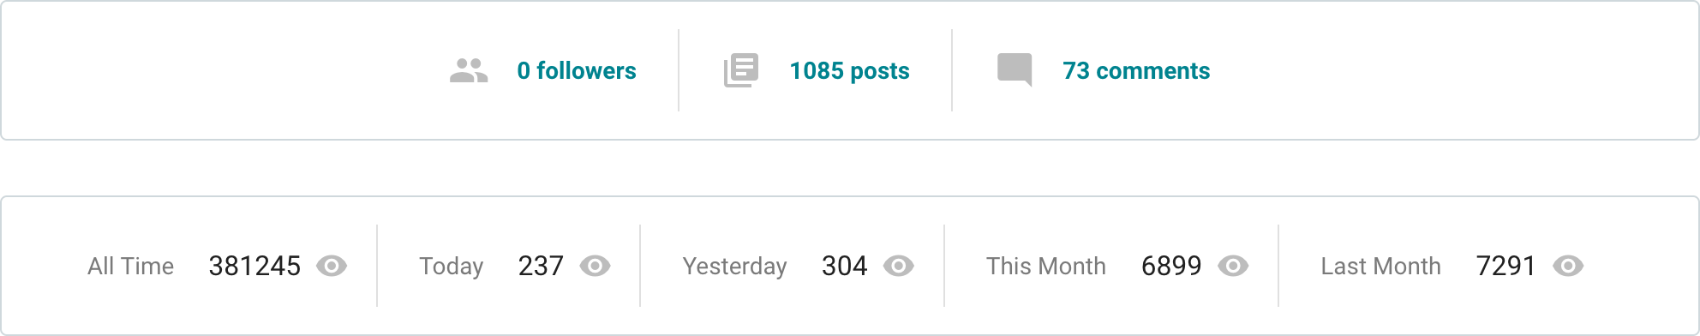
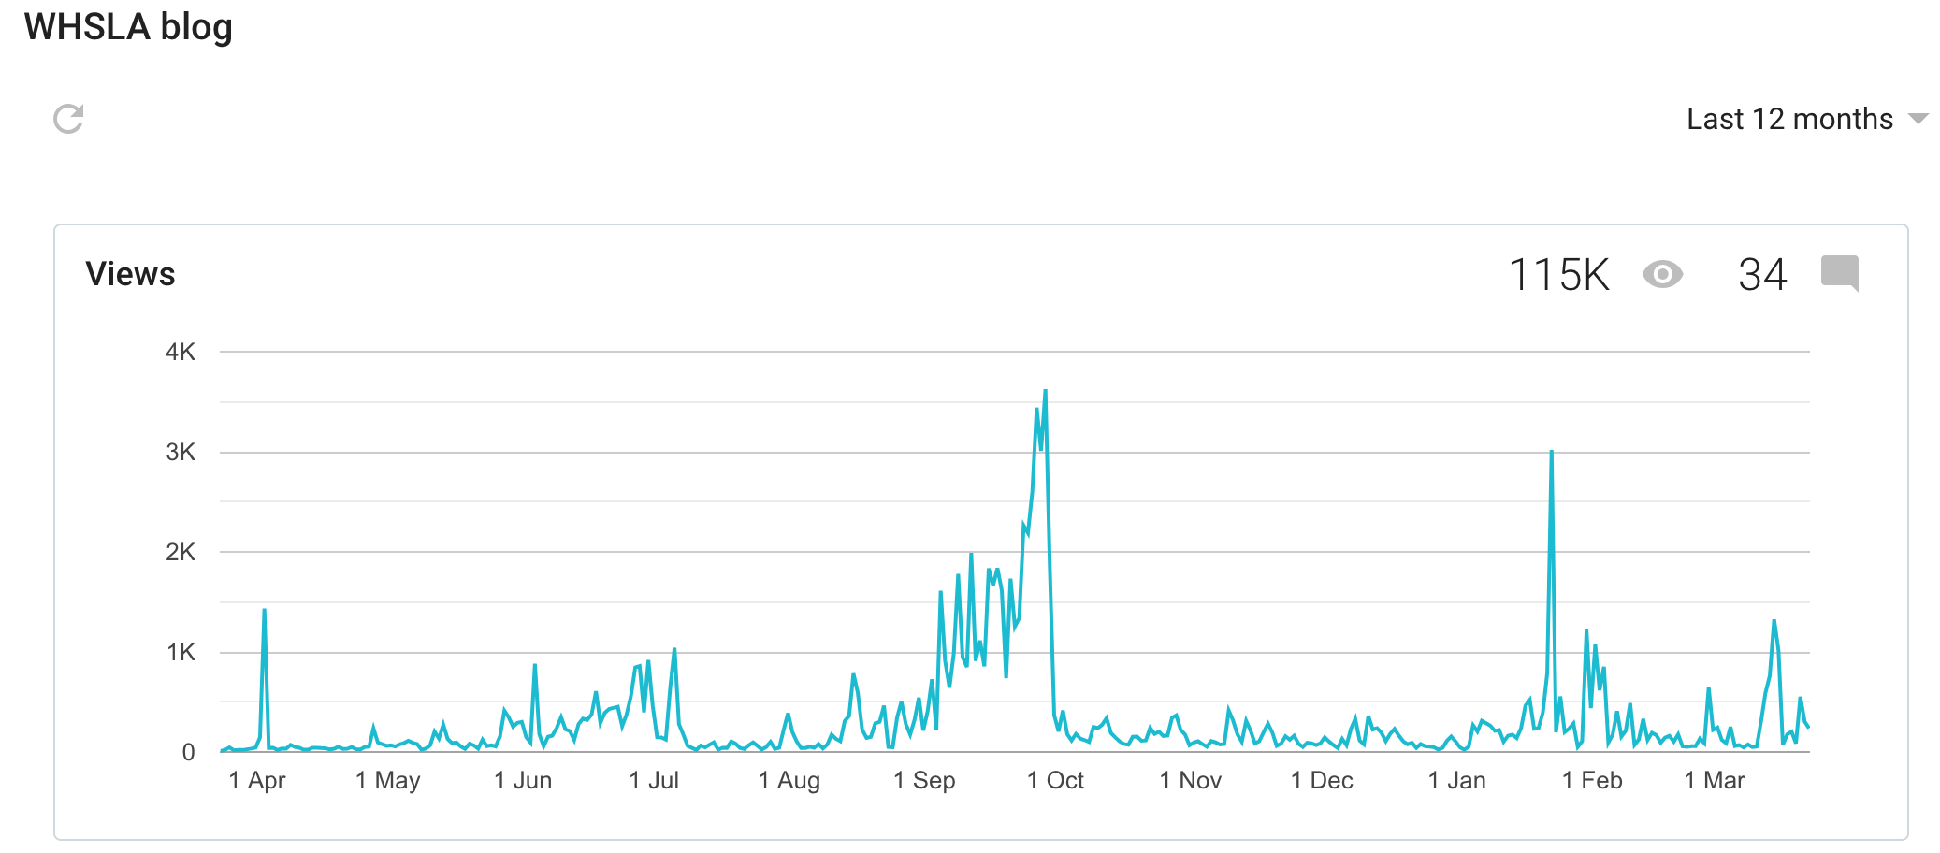

Here are the posts with the most hits.
The number next to the eye on the right shows how many hits the post has logged in it’s lifetime. Keep in mind these are usually older posts that have had time to get more hits. This also shows our audience goes beyond our small group of WHSLA members.
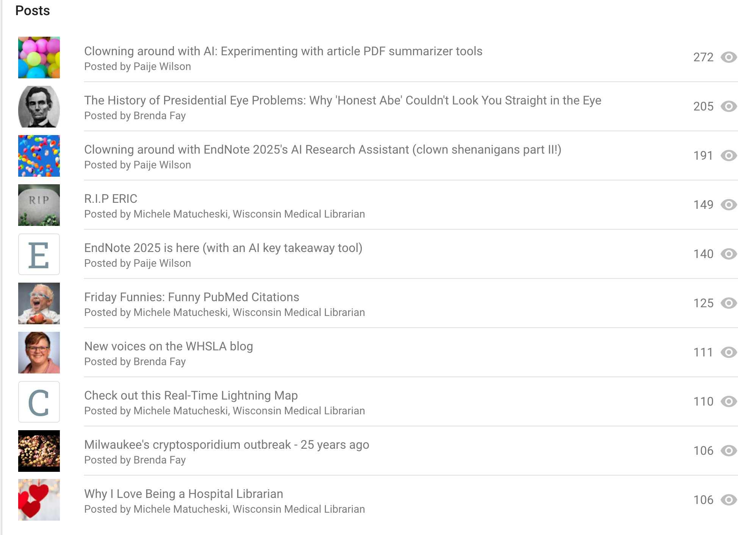

Liz Suelzer manages the WHSLA Website. Contact her if you notice any changes that need to be made to the website.
Respectfully submitted by Michele Matucheski on behalf of Allan Barclay, Liz Suelzer, Paije Wilson and Kelly Johnson.

Membership Coordinator – Jennifer Schram
Currently there are 33 members. We've lost a few but also gained a few so numbers are holding steady.

Midwest Chapter/MLA State Liaison Committee – Rita Michell
MLA is asking chapters to start working on compiling lists of library schools and potential outreach contacts in each state. Barb has largely accomplished this already with our own outreach at UW-Madison and UW-Milwaukee.

Professional Development – Dora Davis
Professional Development Awards
Professional Development entries were collected in January 2026.
The awards will go to the following for MLA attendance funding:
- Michele Matucheski  - Dora Davis  - Rita Mitchell  - Claudia Noonan  - Karen Hanus  - Melinda Orebaugh | - Jennifer Deal  - Megan Olson  - Liz Suelzer  - Kari Zelinka  - Meagan McConnell
And to the following for other funding: Kelly Johnson
Award recipients were notified via email and should submit expenses to Karen Hanus.

MLA Webinars
In the last report, we discussed the limited engagement for previous webinars offered by WHSLA. An average of six members requested codes which represents underutilized spending.
All members are encouraged to express interest for specific webinars by emailing Dora. For the winter/spring of 2026, Dora will not be sending out surveys as many of members are planning to attend the MLA Conference and will have an opportunity to take CE there.
Please look for a survey for summer/fall regarding webinars MLA will have available. Also, any free CE opportunities will continue to be sent to the WHSLA bloggers so please check there often.

Respectfully submitted,
Dora Davis

WHSLA Wisdom Chats – Barb Ruggeri
Upcoming WHSLA Wisdom Chats:
- April: no topic yet (tentative)
- June: Reports/sharing from MLA attendees that used WHSLA awards for funding
- September: AI Copyright (dependent on participant agreement)

Outreach to iSchool and UW-SOIS – Barb Ruggeri
Submitted by Barb Ruggeri, MLIS, AHIP
Immediate Past President

As directed by the Fall Board Meeting vote, I reached out to UW Milwaukee -SOIS (Julie S. Walker Student/Alumni Engagement & Outreach Specialist) and she agreed to send out an email regarding our sponsorship of a student registration for MLA -26. An email to students was sent out 2/20/26 inviting them to apply for the grant.
I also reached out to the Program Director Greg Downey at UW Madison iSchool and he referred me to Tanya Hendricks Cobb, Graduate Program Manager and she sent out the invitation to apply to library school students there on 2/23/26. On March 18, I asked Julie and Tanya to send out a reminder to their students that the deadline was end of day 3-20-26.

We received two applications from qualified applicants. Ms. Rachel Witt from UW- Madison was the selected recipient. I emailed her on 3-26-26 notifying her of her award and procedures to register for MLA. I notified the other applicant that her application was not chosen but told her she is welcome to reach out to me for meeting to learn more about the profession.

If the MLA LAC hospitality committee needs student volunteers, I will send out invitations to the two schools. Students can earn a one-day free pass to attend the conference for 6 hours of volunteer work.

Old Business

Need for new List-serv administrator and list-serve distribution service

Kelly Johnson will be taking over for Allan Barclay when he retires. See Communications report above for additional details.

New Business

Lifetime vs. Emeritus Membership

Michele Matucheski received Lifetime membership award when she retired, but Karen Hanus suggested we change that to an Emeritus designation because Emeritus implies continued involvement with the organization. This change would not be in WHSLA bylaws, just the guidelines, so membership doesn't need to vote and the board alone can vote on this change.

Karen asked the board if we should continue to use the criteria from the current guidelines (limited to people that have been WHSLA members for 5+ years and have also served in a board position). Barb Ruggeri stated that she believed it should be people that have been members for 5+ years, but serving on the board may not be necessary.

Jennifer Schram asked that we include an option on the membership form for Emeritus so they can continue to renew their membership annually. Then we'll know not to charge them membership dues, but at least we'll know they still have interest and have up to date contact information. Karen requested that we also add something for student member as well as hardship on form so that we can capture all possible member statuses.

It was agreed that Emeritus members should have the same benefits/privileges as all members.

Board cast a unanimous vote on making these changes. Hayley will draft something for guidelines (currently under "President's Duties") and reach out to Liz to make changes to membership form when the time comes.

MLA Blanket Making Party at MLA ’26 – Karen Hanus

- WHSLA sponsorship of ten blanket kits ($15.75 per)
The MLA local planning committee has partnered with My Very Own Blanket which supports the creation of handmade blankets that are donated to foster care agencies all over the world and given to foster care children. At MLA there will be a blanket making party. Attendees can buy a kit to make a no-sew blanket.

Karen made a motion to purchase 10 blanket making kits from MLA – Liz seconded the motion.
Vote was unanimous in approval of the motion.

MLA 2026 or WHSLA 2026 in-person meeting? – Hayley Severson

There was continued discussion around when/how to hold a WHSLA social event during MLA.
Several days/times wouldn't work because they would coincide with competing events like the Welcome Reception/Exhibit Hall and caucus lunches on Wednesday. There was concern that a dinnertime event wouldn't be as well attended. This left breakfast or lunch on Thursday or Friday.
Hayley suggested holding the WHSLA social event one of the grab and go lunches – we could lure people with the idea of getting their lunch during a WHSLA get together. Barb suggested 3rd Street Marke. Members could easily walk there from the conference center as it's only a 3-minute walk.
Karen said members could take a photo of their receipt to request reimbursement for lunch. Hayley requested that we come up with some loose guidelines for what we will cover (up to what dollar amount and no alcohol, for example).
Rita Mitchell requested regular seating rather than bar stools to make it accessible for everyone.
Final decision: 3rd street market, Thursday 5/21 at noon
Hayley will email the membership with this plan once the parameters for meal reimbursement are set.

Other Topics
Barb Ruggeri reminded us that September 1977 was when WHSLA was created, meaning next year will be our 50th anniversary. We may want to do something in person next year in honor of that. From Karen/website: "On September 16, 1977 in La Crosse, a business meeting was held after a general program. The bylaws of the Wisconsin Health Science Library Association were presented and discussed. The bylaws were accepted by thirty people in attendance and the annual dues were set at $5. WHSLA was formally created."
Karen suggested we think about a formal process for when people retire. Karen did a KudosBoard for Michele Matucheski which had a small associated cost. Perhaps we need something in the guidelines about what we should do beyond the "Lifetime" membership option.

Adjournment
Board meeting adjourned by Hayley Severson at 2:07 PM. Informal sharing followed.

